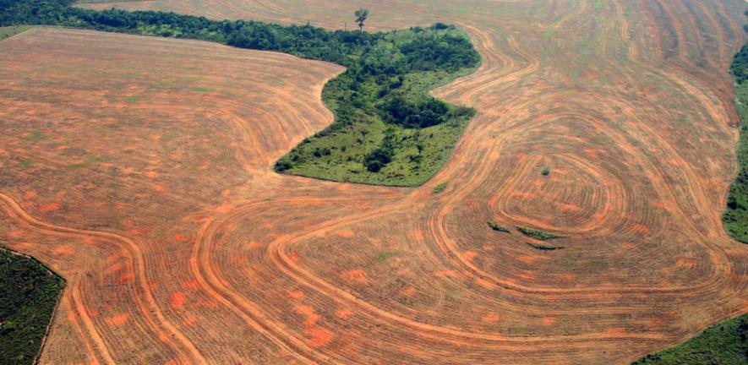

**DEFORESTATION TREND FROM 1990 TO 2016**

|  |  |
| --- | --- |
| SQL PROJECT |  |

SQL Project Coding

**CREATION:**  
DROP VIEW IF EXISTS forestations;

CREATE VIEW forestations AS

SELECT f.country_code AS fcode,

f.country_name AS fname,

f.forest_area_sqkm,

f.year AS fyear,

l.country_code AS lcode,

l.country_name AS lname,

l.total_area_sq_mi,

l.total_area_km,

f.forest_area_sqkm/NULLIF (l.total_area_km,0) AS percentage,

l.year AS lyear,

r.country_name AS rname,

r.country_code AS rcode,

r.region,

r.income_group

FROM forest_area f

JOIN land_area l

ON f.country_code = l.country_code AND f.year = l.year

JOIN regions r

ON l.country_code = r.country_code;

SELECT ROUND (percentage*100)AS forest_percentage

FROM forestations

PART #1 GLOBAL SITIUATION  
**a.**  
SELECT fyear, SUM(forest_area_sqkm) AS total_forest_area

FROM forestations

WHERE fyear='1990' AND fname='World'

GROUP BY fyear;

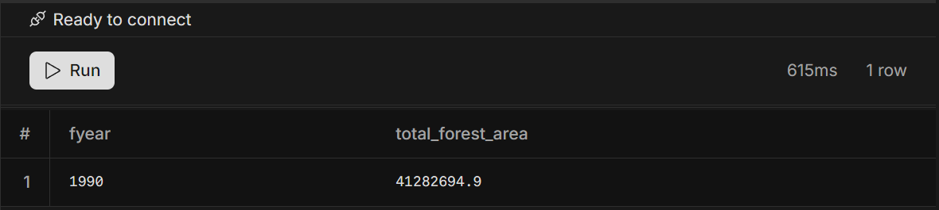

**B.**

SELECT fyear,

SUM(forest_area_sqkm) AS total_forest_area

FROM forestations

WHERE fyear='2016' AND fname='World'

GROUP BY fyear;

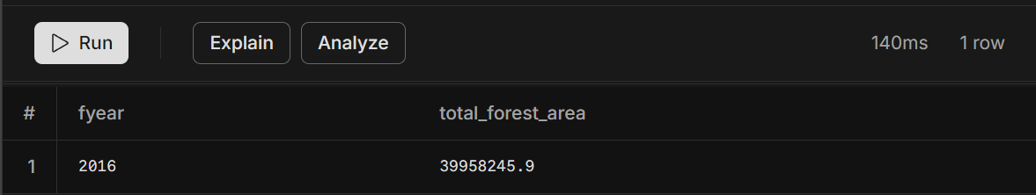

**C.**

SELECT

(SELECT forest_area_sqkm

FROM forestations

WHERE fyear = 1990 AND fname='World') -

(SELECT forest_area_sqkm

FROM forestations

WHERE fyear = 2016 AND fname='World') AS Change_forest_area

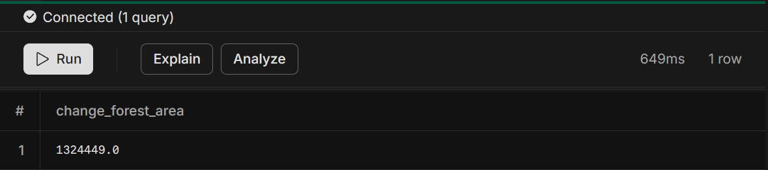

**d.**

WITH forest_area_1990 AS (

SELECT SUM (forest_area_sqkm) AS forest_area_1990

FROM forestations

WHERE fyear = 1990

AND fname = 'World'

),

forest_area_2016 AS (

SELECT SUM(forest_area_sqkm) AS forest_area_2016

FROM forestations

WHERE fyear = 2016

AND fname = 'World'

)

SELECT

((f2016.forest_area_2016 - f1990.forest_area_1990) / f1990.forest_area_1990) * 100 AS percent_change

FROM

forest_area_1990 f1990,

forest_area_2016 f2016;  
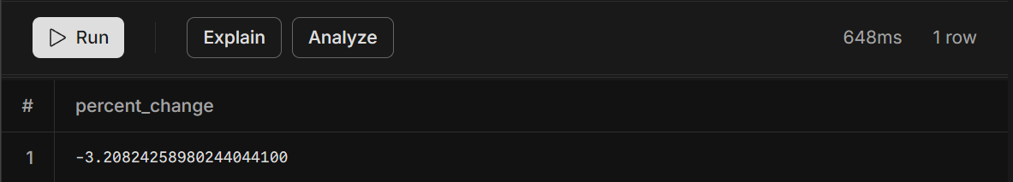

**e.**  
WITH forest_area_1990 AS (

SELECT SUM (forest_area_sqkm) AS forest_area_1990

FROM forestations

WHERE fyear = 1990

AND fname = 'World'

),

forest_area_2016 AS (

SELECT SUM(forest_area_sqkm) AS forest_area_2016

FROM forestations

WHERE fyear = 2016

AND fname = 'World'

),

loss_change_2016_1990 AS (

SELECT (f1990.forest_area_1990 - f2016.forest_area_2016) AS loss_change

FROM

forest_area_1990 f1990,

forest_area_2016 f2016)

SELECT f.fname,

f.total_area_km,

cte.loss_change,

ABS(f.total_area_km - cte.loss_change) AS difference

FROM forestations f,

loss_change_2016_1990 cte

WHERE fyear = 2016

ORDER BY difference ASC

LIMIT 5;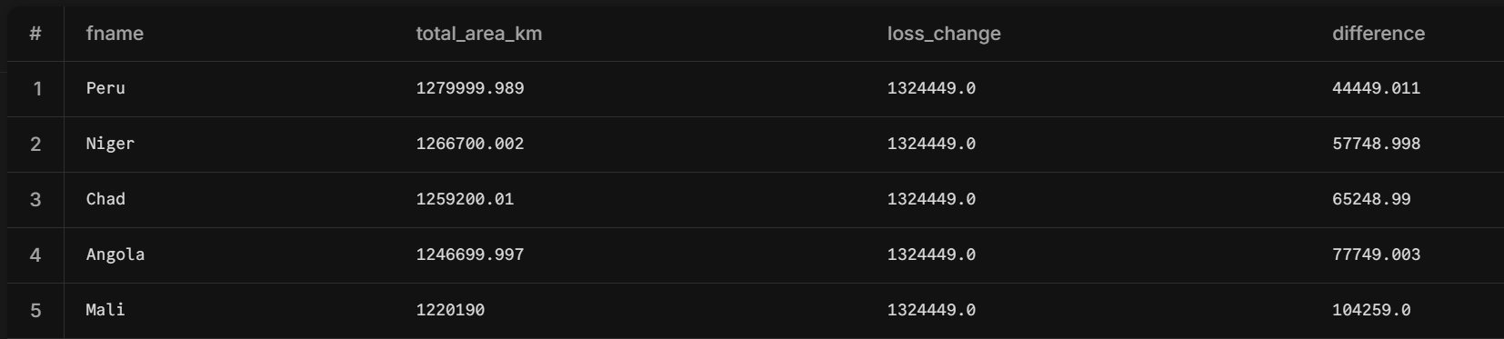

# PART#2 Regional Outlook

DROP TABLE IF EXISTS region_forest_percentages;

CREATE TABLE region_forest_percentages (

region VARCHAR(512),

percent_forest_area_1990 DECIMAL(5,2),

percent_forest_area_2016 DECIMAL(5,2)

);

INSERT INTO region_forest_percentages (region, percent_forest_area_1990, percent_forest_area_2016)

WITH region_forest_area AS (

SELECT r.region,

f.year,

SUM(f.forest_area_sqkm) AS total_forest_area,

SUM(l.total_area_sq_mi * 2.59) AS total_land_area

FROM regions r

INNER JOIN forest_area f

ON r.country_code = f.country_code

INNER JOIN land_area l

ON r.country_code = l.country_code AND f.year = l.year

GROUP BY r.region, f.year

)

SELECT region,

SUM(CASE WHEN year = 1990 THEN total_forest_area / total_land_area ELSE 0 END) * 100 AS percent_forest_area_1990,

SUM(CASE WHEN year = 2016 THEN total_forest_area / total_land_area ELSE 0 END) * 100 AS percent_forest_area_2016

FROM region_forest_area

GROUP BY region;

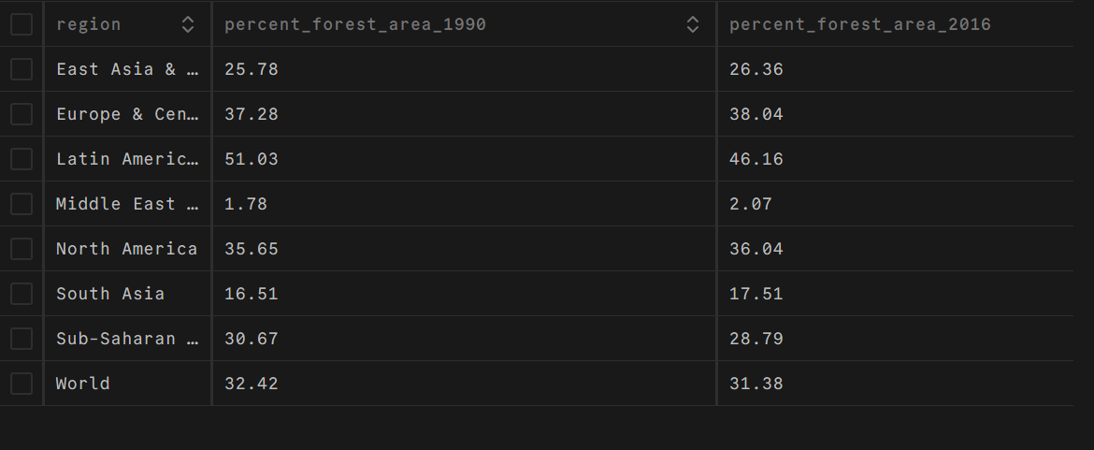

**a.**

SELECT region, percent_forest_area_2016

FROM region_forest_percentages

WHERE region='World'

ORDER BY 2;

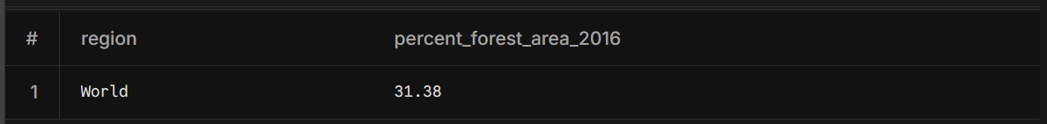

SELECT region, percent_forest_area_2016

FROM region_forest_percentages

ORDER BY 2 ASC;

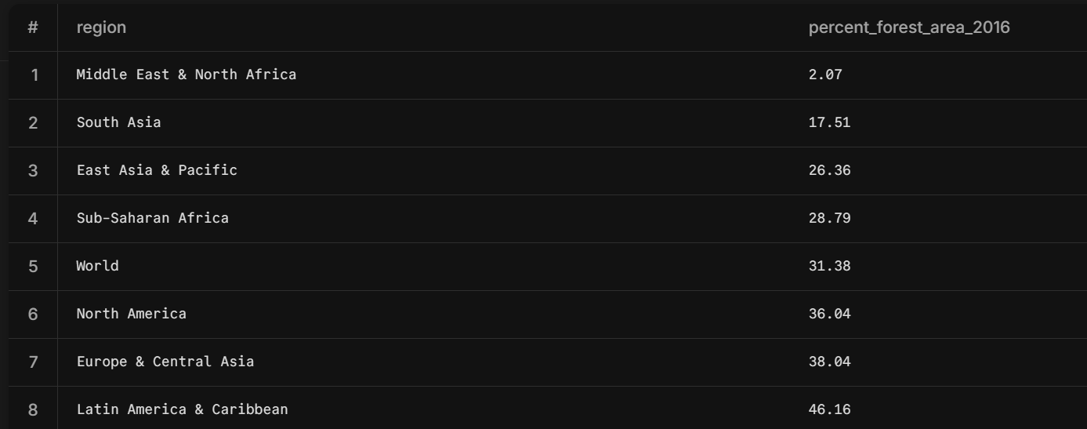

**b.**

SELECT region, percent_forest_area_1990

FROM region_forest_percentages

WHERE region='World'

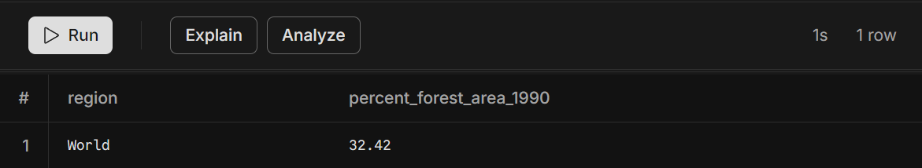

SELECT region, percent_forest_area_1990

FROM region_forest_percentages

ORDER BY 2 ASC;

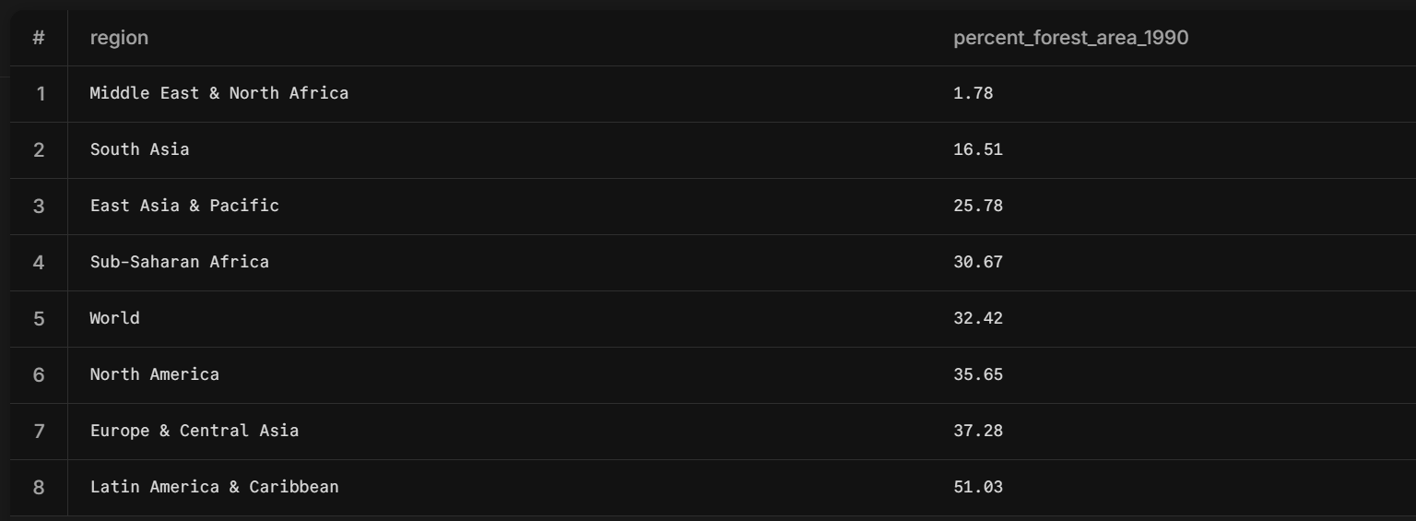

**c.**

SELECT region, (percent_forest_area_2016 - percent_forest_area_1990) AS decreasing

FROM region_forest_percentages

WHERE (percent_forest_area_2016 - percent_forest_area_1990) < 0

ORDER BY 2;

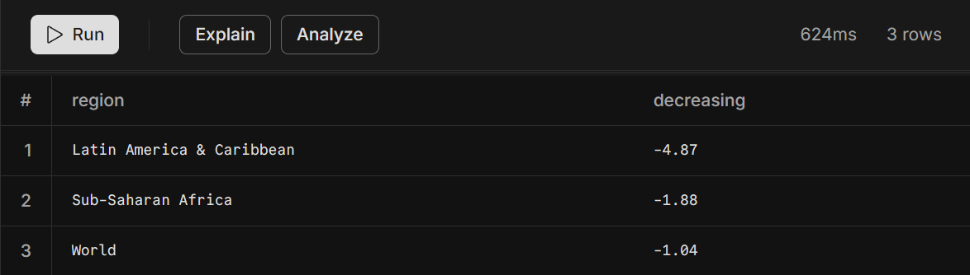

# Part#3 Country-Level Detail

**a.**

WITH forest_area_country AS (

SELECT fname,

SUM(CASE WHEN fyear = 1990 THEN forest_area_sqkm ELSE 0 END) AS forest_area_1990,

SUM(CASE WHEN fyear = 2016 THEN forest_area_sqkm ELSE 0 END) AS forest_area_2016

FROM forestations f

GROUP BY fname

)

SELECT f.fname,

f.forest_area_1990,

f.forest_area_2016,

f.forest_area_1990 - f.forest_area_2016 AS loss_change

FROM forest_area_country f

ORDER BY loss_change DESC

LIMIT 6;

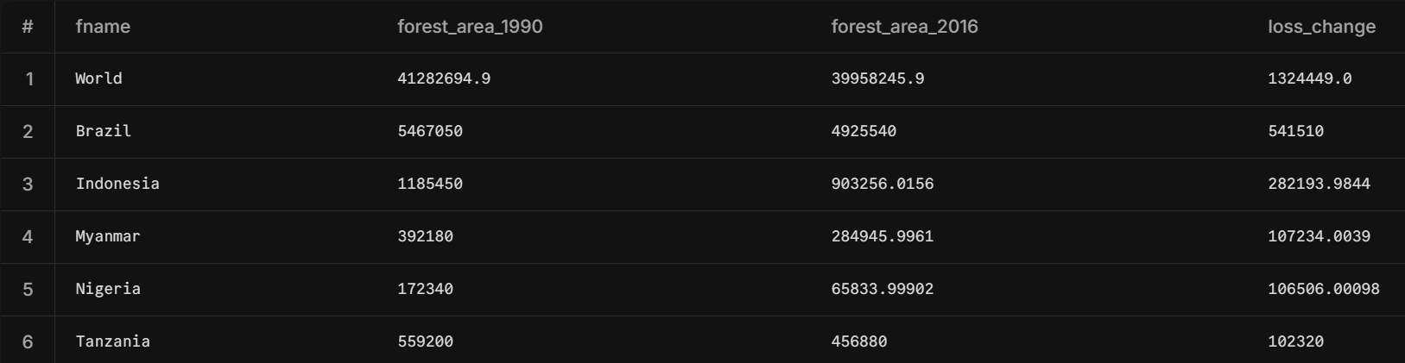

**b.**

WITH forest_area_by_country AS (

SELECT fname,

SUM(CASE WHEN fyear = 1990 THEN forest_area_sqkm ELSE 0 END) AS forest_area_1990,

SUM(CASE WHEN fyear = 2016 THEN forest_area_sqkm ELSE 0 END) AS forest_area_2016

FROM forestations f

GROUP BY fname

)

SELECT fr.fname,

fr.forest_area_1990,

fr.forest_area_2016,

ROUND(((fr.forest_area_2016 - fr.forest_area_1990) / fr.forest_area_1990) * 100, 2) AS percent_change

FROM forest_area_by_country fr

WHERE fr.forest_area_1990 > 0

ORDER BY percent_change ASC

LIMIT 5;  
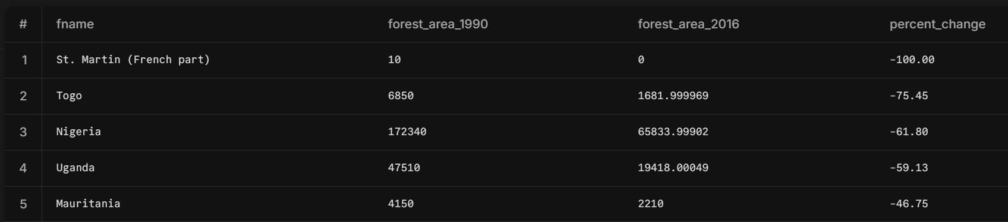

**c.**

WITH compare_percent AS(

SELECT percentage AS us_forestation_percentage

FROM forestations

WHERE fname = 'United States' AND fyear = 2016

)

SELECT COUNT(*) AS countries_with_higher_forestation

FROM forestations

WHERE fyear = 2016 AND

percentage > (SELECT us_forestation_percentage

FROM compare_percent);

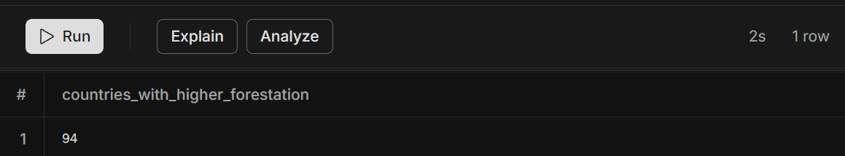

**Our insights**

**The correlation between income classification and the level of desertification in countries**

SELECT r.country_name,

r.income_group

FROM Regions r

WHERE r.country_name = 'Brazil' OR r.country_name = 'Indonesia' OR r.country_name = 'Myanmar' OR r.country_name = 'Nigeria' OR r.country_name = 'Tanzania'

GROUP BY r.country_name, r.income_group

ORDER BY r.country_name;

